Exercise 3: Sorting Customer Orders
Understand Sorting Algorithms
- Bubble Sort
- Compares and swaps adjacent items until the list is sorted.
- Simple to implement but becomes very slow as the list grows.
- Insertion Sort
- Builds the final sorted list by placing each item in its correct position.
- Works well for small or mostly sorted data but is slow for large lists.
- Quick Sort
- Picks a pivot and organizes items around it using divide-and-conquer.
- Very fast in most cases and widely used in real applications.
- Merge Sort
- Splits the list, sorts each part, and merges them together.
- Gives reliable performance and handles large lists well.
Output
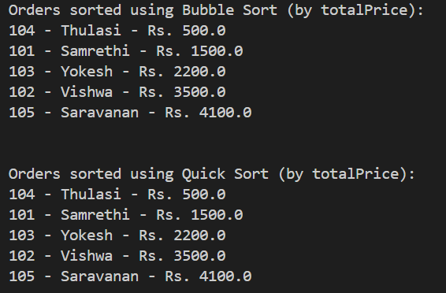
Time Complexity Comparison
- Bubble Sort is slow overall, especially for big lists.
- Quick Sort is much faster and more efficient in general cases.
Why Quick Sort is Preferred
- Handles large data better due to faster sorting.
- More practical and widely used compared to basic sorting methods.

